13.5   


a) The mean NPV is approximately $2.9 million.  
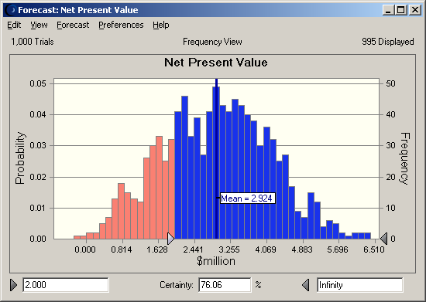

b) The probability that the NPV will be at least $2 million is approximately 76%.

c) The mean value of the minimum annual operating profit is approximately $0 million.  
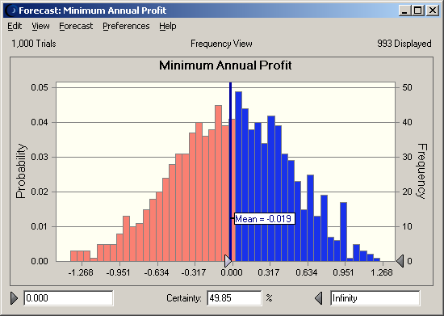

d) The probability that the minimum annual operating profit will be at least $0 million is approximately 49.9%.

13.8   


The mean claim is approximately $2,750.  
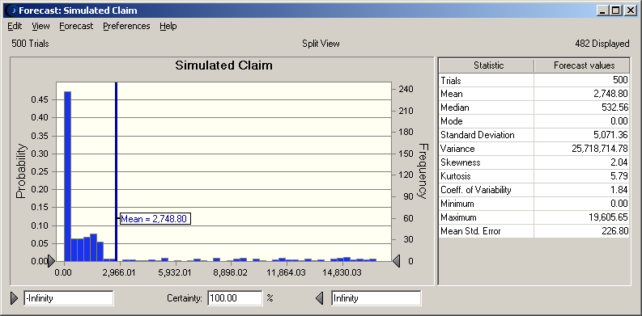

13.12 a) Option 2 (Hotel Project only):  
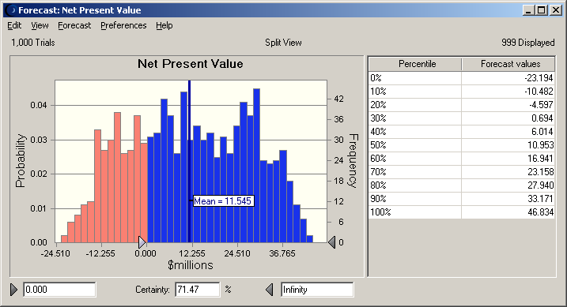

b) Option 3 (Shopping Center Project only):  
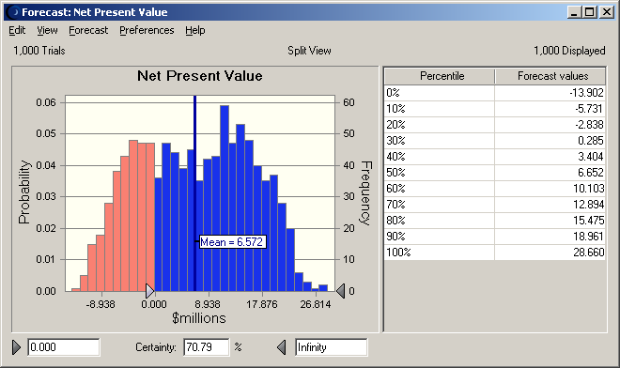

c) Option 1 appears to be the best. It has the highest expected NPV ($18 million vs. less than $12 million vs. less than $7 million) *and* there is less chance of losing money (less than 20% vs. greater than 25% for options 2 and 3).

[Capital Budgeting](http://www.wfu.edu/~akinc/FIN203/hanes_soln.xls)