Practice test for final exam

This is a very short practice exam. It only deals with the material that we covered recently.
Since the final is a comprehensive exam, you should absolutely also go through your previous exams and practice exams. Also go through the homework assignments. Also go through all the problems we did in class.
Understand the concepts. Go through the lecture notes.

Notice: Optics and nuclear physics will not be on the exam

- The test consists of two parts. Part 1 has multiple-choice questions and Part 2 has longer questions.

- In the multiple-choice part, it is possible that more than one answer is correct.

- The number of points awarded for the correct answer is indicated below each problem. Partial credit will be given for partially correct answers.

Acceleration due to gravity: 9.8 m/s²

- An image is projected on a screen. The image is
a. Real
- Virtual
- Cannot be determined from the information given
(1 points) Not in 2019

- In class I was projecting the image of a light bulb onto the wall. I then put a piece of paper that had a small square hole in it, (small square aperture) in front of the lens. What happened?
  - The image became dimmer
  - The image became smaller
  - The depth of focus was increased
  - The image had a square outline, because the aperture was square.
(3 points) Not in 2019

3. A transformer is converting 120 V in the primary circuit to 12V in the secondary circuit. If the current in the secondary circuit is 1 A, what current is flowing in the primary circuit?
a. 10 A
b. 100 A
c. 12 A
- 0.1 A
- None of the above. My answer is _______________________________

4. If the primary coil in question 1 has 200 windings, how many coils does the secondary coil have?
a. 12
- 120
- 2000
- 20
- None of the above. My answer is _____________________________

5. Power companies use AC rather DC because
a. There is less risk of electrocution.
b. AC generates less electric field.
- transformers can work only on AC.
- heaters work only on AC.
- None of the above. My answer is _______________________________________

9. It is better to send 100 kW of electrical power at 100,000 volts than at 120 volts because:
a. there is less energy wasted heating wires.
b. higher voltage is safer.
c. the resistance of the wires is less at higher voltage.
- insulation is more effective at higher voltage.
- None of the nonsense above. The real reason is __________________________________

11. If the diameter of a wire increases, its resistance
a. increases.
b. decreases.
c. does not change.
- will increase or decrease depending on the composition.
- None of the above. My answer is __________________________

12. If the lenght of a wire increases, its resistance
a. increases.
b. decreases.
- does not change.
- will increase or decrease depending on the composition.
- None of the above. My answer is __________________________

13. Electromagnetic induction is the following
- a changing voltage causes a changing current
- a changing current causes a changing magnetic field
- a changing magnetic field causes a current
- a changing voltage causes a changing magnetic field

16. Which of the following is true for permanent magnets.
- They always have a north and a south pole (they are dipoles)
- When you cut a magnet in half you get two pieces, one north pole and one south pole
- When you cut a magnet in half you get two pieces, each having a north and a south pole
- Like poles attract.
- Like poles repel.

17. A steel paper clip is normally not magnetic. However, when you touch one end of the paper clip to the north end of a permanent magnet, the paper clip becomes magnetic. Which end of the paper clip becomes a south pole?

18. Junk yards use large direct current electromagnets to pick up scrap iron and steel. Why don’t they use alternating current in those electromagnets.

- What does "92" represent in ⁹²U? Not in 2019
a. The number of protons.
- The number of neutrons.
- The total number of protons and neutrons.
- The number of electrons.

- What does "235" represent in Uranium 235? Not in 2019
- The number of protons.
- The number of neutrons.
- The total number of protons and neutrons.
- The number of electrons.

- The combining of two nuclei to form a large nucleus with a release of energy is Not in 2019
a. nuclear fission.
b. nuclear fusion.
c. neutron activation.
d. nuclear emission.
e. beta decay.

- The splitting of a nucleus to form two or more, smaller nuclei with a release of energy is Not in 2019
a. nuclear fission.
b. nuclear fusion.
c. neutron activation.
d. nuclear emission.
e. beta decay.

- Critical mass is Not in 2019
a. the mass need to initiate a chain reaction.
- the mass of nucleus that is radioactive.
- the sum of the proton and neutron masses in a nucleus.
- the mass needed to shield a radioactive source.

- Optics and lenses Not in 2019
  - How could the vision of a far-sighted person be corrected? Draw a lens into the box below and show how the light rays from the object could be focused on the retina instead of behind it.
Retina
Eye lens
Glasses
?
(3 points)

  - When it is bright, a cat’s iris will contract into a very thin slit. When looking at a round object, what shape will the object have on the cat’s retina? Will the depth of focus increase or decrease as the iris gets smaller?

  - The transformer for the WFU campus is located across University Parkway.
- What is the purpose of the WFU transformer?
- Why do power companies like transformers?

  - Magnets and electric DC motors.
- What happens to the microscopic magnetic domains when a magnet is “magnetized”?
- A DC motor consists of a permanent magnet and an electromagnet that changes is polarity. Why does the electromagnet have to change its polarity for the motor to work?
- In the diagram (a, b,d) below, draw in the direction in which the electromagnet is pulled (Note the change in direction of the current?

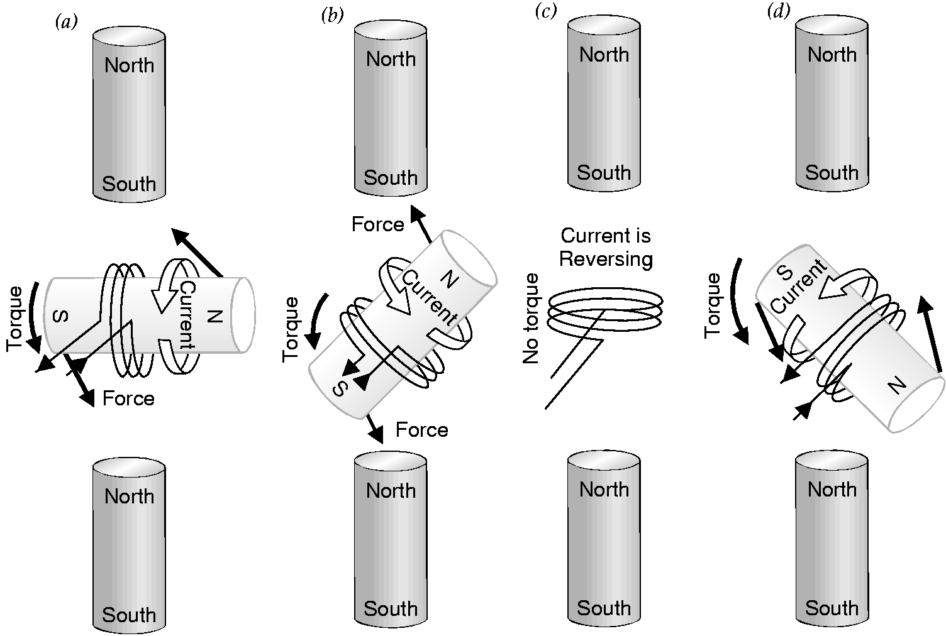

Solutions: 1a; 2a,c; 3d, 4d, 5c, 9a, 11b, 12a, 13c, 16ace, 17(see notes), 18 load would drop when current is zero, (optics: also see homework problems), 19a; 20c; 21b; 22a, 23a

2a. Power is transmitted at very high voltages from the power plants. The transformer steps this voltage down to 120 V.
2b. Power is transmitted at high voltages and low currents. The power loss in the wire is P = RI² (proportional to I²). This mode of transmission (high V and low I) minimizes the loss of power in the wires.

3a They get aligned
3b Without a change in polarity, the motor would get stuck.
3c South pole to north pole, and north pole to south pole

