Practice Test for Midterm 2

You may use a 3x5 inch cheat card

Acceleration due to gravity: g = 9.80m/s²
Mass of Earth M_{E} = 5.98⋅10²⁴ kg
Mass of Sun M_{s} = 1.99⋅10³⁰ kg
Radius of Earth R_{E} = 6.37⋅10⁶ m
Density of water ρ_{water} =1000 kg/m³
Standard atmospheric pressure P₀ = 1.013⋅10⁵ Pa

Moments of inertia: see second to last page

In preparation for the Midterm exam go through the practice tests, go through the homework problems and through the problems we did in class
Understand the concepts and what the formulas mean!!
Answer key: last page

----------------------------------------------------------

Chapter 7

20. A 3.0-kg block is dragged over a rough horizontal surface by a constant force of 16 N acting at an angle of 37° below the horizontal as shown. The speed of the block increases from
4.0 m/s to 6.0 m/s in a displacement of 5.0 m. What work was done by the friction force during this displacement?
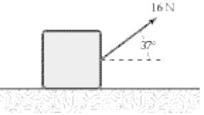

a. –34 J
b. –64 J
c. –30 J
d. –94 J
e. +64 J

30. A 10-kg block on a horizontal frictionless surface is attached to a light spring (force constant = 0.80 kN/m). The block is initially at rest at its equilibrium position when a force (magnitude P = 80 N) acting parallel to the surface is applied to the block, as shown. What is the speed of the block when it is 13 cm from its equilibrium position?

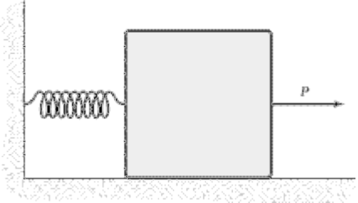

a. 0.85 m/s
b. 0.89 m/s
c. 0.77 m/s
d. 0.64 m/s
e. 0.52 m/s

47. Two vectors A and B are given by A = 5i + 6j + 7k and B = 3i – 8j + 2k. If these two vectors are drawn starting at the same point, what is the angle between them?

a. 106°
b. 102°
c. 110°
d. 113°
e. 97°

Chapter 8

8. A 0.60-kg object is suspended from the ceiling at the end of a 2.0-m string. As this suspended object swings, it has a speed of 4.0 m/s at the lowest point of its path. What maximum angle does the string make with the vertical as the object swings?

a. 61°
b. 54°
c. 69°
d. 77°
e. 47°

17. A 2.0-kg mass is projected from the edge of the top of a 20-m tall building with a velocity of 24 m/s at some unknown angle above the horizontal. Disregard air resistance and assume the ground is level. What is the kinetic energy of the mass just before it strikes the ground?

a. 0.18 kJ
b. 0.97 kJ
c. 0.89 kJ
d. 0.26 kJ
e. 0.40 kJ

19. A skier weighing 0.80 kN comes down a frictionless ski run that is circular (R = 30 m) at the bottom, as shown. If her speed is 12 m/s at point A, what is her speed at the bottom of the hill (point B)?

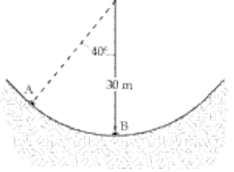

a. 17 m/s
b. 19 m/s
c. 18 m/s
d. 20 m/s
e. 12 m/s

20. Problem 19 but now assuming that there is friction with a frictional coefficient of μk = 0.1
(no answer key)

25. A 1.0-kg block is released from rest at the top of a frictionless incline that makes an angle of 37° with the horizontal. An unknown distance down the incline from the point of release, there is a spring with k = 200 N/m. It is observed that the mass is brought momentarily to rest after compressing the spring 0.20 m. What distance does the mass slide from the point of release until it is brought momentarily to rest?

a. 0.98 m
b. 0.68 m
c. 0.82 m
d. 0.55 m
e. 0.20 m

33. A 12-kg projectile is launched with an initial vertical speed of 20 m/s. It rises to a maximum height of 18 m above the launch point. How much work is done by the dissipative (air) resistive force on the projectile during this ascent?

a. –0.64 kJ
b. –0.40 kJ
c. –0.52 kJ
d. –0.28 kJ
e. –0.76 kJ

Chapter 9+10

10. An 8.0-kg object moving 4.0 m/s in the positive x direction has a one-dimensional collision with a 2.0-kg object moving 3.0 m/s in the opposite direction. The final velocity of the 8.0-kg object is 2.0 m/s in the positive x direction. What is the total kinetic energy of the two-mass system after the collision?

a. 32 J
b. 52 J
c. 41 J
d. 25 J
e. 29 J

13. A 2.0-kg object moving with a velocity of 5.0 m/s in the positive x direction strikes and sticks to a 3.0-kg object moving with a speed of 2.0 m/s in the same direction. How much kinetic energy is lost in this collision?

a. 2.4 J
b. 9.6 J
c. 5.4 J
d. 0.6 J
e. 6.0 J

17. A 6.0-kg object moving 5.0 m/s collides with and sticks to a 2.0-kg object. After the collision the composite object is moving 2.0 m/s in a direction opposite to the initial direction of motion of the 6.0-kg object. Determine the speed of the 2.0-kg object before the collision.

a. 15 m/s
b. 7.0 m/s
c. 8.0 m/s
d. 23 m/s
e. 11 m/s

28. A 3.0-kg object moving in the positive x direction has a one-dimensional elastic collision with a 5.0-kg object initially at rest. After the collision the 5.0-kg object has a velocity of 6.0 m/s in the positive x direction. What was the initial speed of the 3.0 kg object?

a. 6.0 m/s
b. 7.0 m/s
c. 4.5 m/s
d. 8.0 m/s
e. 5.5 m/s

31. Two blocks with masses 2.0 kg and 3.0 kg are placed on a horizontal frictionless surface. A light spring is placed in a horizontal position between the blocks. The blocks are pushed together, compressing the spring, and then released from rest. After contact with the spring ends, the 3.0-kg mass has a speed of 2.0 m/s. How much potential energy was stored in the spring when the blocks were released?

a. 15 J
b. 3.0 J
c. 6.0 J
d. 12 J
e. 9.0 J

35. A 5.0-g particle moving 60 m/s collides with a 2.0-g particle initially at rest. After the collision each of the particles has a velocity that is directed 30° from the original direction of motion of the 5.0-g particle. What is the speed of the 2.0-g particle after the collision?

a. 72 m/s
b. 87 m/s
c. 79 m/s
d. 94 m/s
e. 67 m/s

Chapter 11 and 12

- The rigid object shown is rotated about an axis perpendicular to the paper and through point P. The total kinetic energy of the object as it rotates is equal to 1.4 J. If M = 1.3 kg and L = 0.50 m, what is the angular velocity of the object? Neglect the mass of the connecting rods and treat the masses as particles.

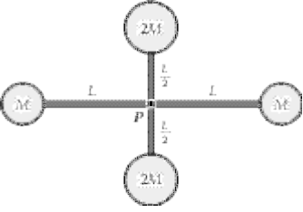
a. 1.3 rad/s
b. 1.5 rad/s
c. 1.7 rad/s
d. 1.2 rad/s
e. 2.1 rad/s

28. What is the angular momentum of the system?

48. The rigid body shown rotates about an axis through its center of mass and perpendicular to the paper. If M = 2.0 kg and L = 80 cm, what is the kinetic energy of this object when its angular speed about this axis is equal to 5.0 rad/s? Neglect the mass of the connecting rod and treat the masses as particles.

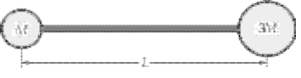

a. 18 J
b. 15 J
c. 12 J
d. 23 J
e. 26 J

3. A particle located at the position vector r = (i + j) m has a force F = (2i + 3j) N acting on it. The torque about the origin is:

a. (1k)N m
b. (5k)N m
c. (–1k)N m
d. (–5k)N m
e. (2i + 3j)N m

15. A puck on a frictionless air hockey table has a mass of 5.0 g and is attached to a cord passing through a hole in the surface as in the figure. The puck is revolving at a distance 2.0 m from the hole with an angular velocity of 3.0 rad/s. The cord is then pulled from below, shortening the radius to 1.0 m. The new angular velocity (in rad/s) is

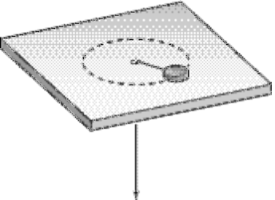

a. 4.0
b. 6.0
c. 12
d. 2.0
e. 8.0

What is the rotational kinetic energy before and after pulling on the string?

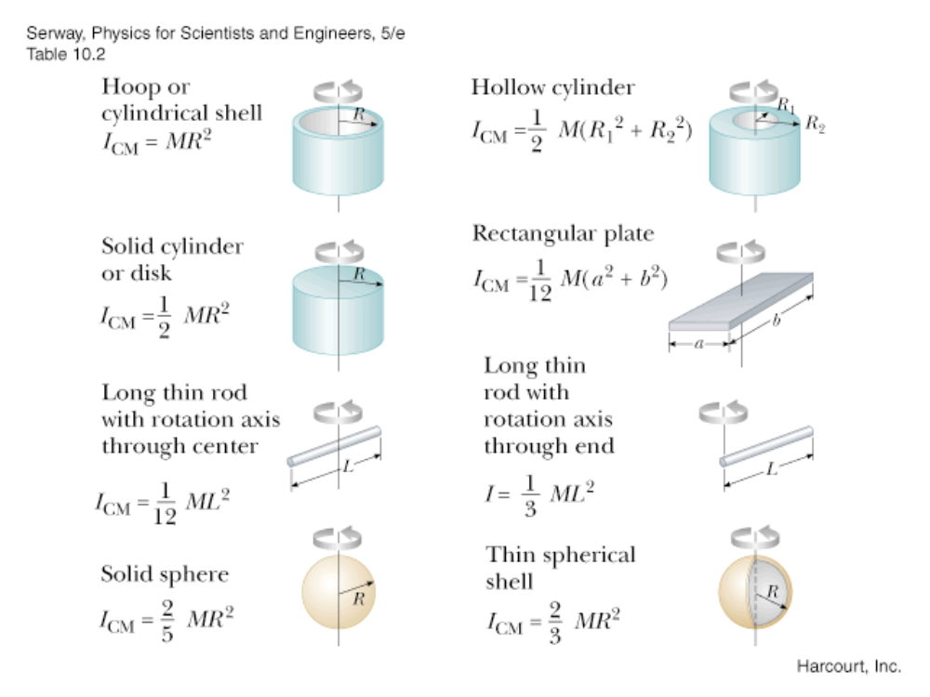

Chapter 7
20. Answer: a
30. Answer: a
47. Answer: b

Chapter 8
8. Answer: b
17. Answer: b
- Answer: a
- (no Answer key)
25. Answer: b
33. Answer: d

Chapter 9
10. Answer: c
13. Answer: c
17. Answer: d
28. Answer: d
31. Answer: a
35. Answer: b

Chapter 10 and 11

Answers:
27c
28:
48 c
3a
15c
2b
15c
8b

