Coastal Barrier Island Network (CBIN) Indigenous Scholar 2010
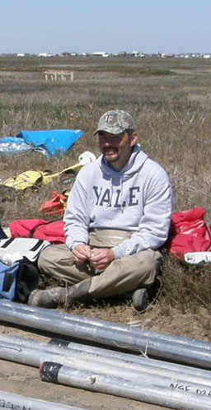
(NSF,RCN Program)
Rusty A. Feagin (Principal Investigator) & David Hurst Thomas (co-Principal Investigator)
feaginr@tamu.edu

Jeffrey Ross is the CBIN Indigenous Scholar. Jeffrey received his B.S. in Resource Conservation from the University of Montana, and his M.S. from Yale University. He has also spent time studying cultural resource management and the history of indigenous peoples at the University of Tromsø in Norway. He now studies at Texas A&M University.

Jeffrey’s research focus is on the impacts of climate change on indigenous cultural resources. He seeks to inform the local decision-making processes and future management strategies of indigenous communities along the North American coast by providing them with an accurate, cost-effective method of assessing the ecological and socioeconomic impacts associated with a changing climate. He plans to do this within a Geographic Information System (GIS), and assess the effectiveness of indigenous technologies to restore degraded coastal areas and protect cultural resources.
People have lived and made their livelihood along coastal North America for at least 10,000 years. Over this time period, sea levels have generally risen and many extreme storm events have occurred, and yet various indigenous cultures have survived and adapted to the changes. Much archeological evidence of previous site habitation and usage sits just above the current sea level and is at high risk to potential climate change impacts. Today, we have the opportunity to evaluate the risk to these sites, and to do so in the form of a scholarship that will be marketed towards those with knowledge of their cultural significance.
We propose to fund a graduate student scholarship that will be directed towards students from indigenous cultures in North America, including Native Americans and First Nations, to explore these issues. The scholarship will fund participation in CBIN as well as 2 years of study in a Master of Science program at the Department of Ecosystem Science & Management at Texas A&M University, to be focused upon creating a ranked list of indigenous cultural sites that are at the highest risk for destruction due to climate change impacts along the North American coast.

Scholarship Parameters
The scholarship will be primarily marketed towards those with indigenous cultural affiliation, including Native Americans and First Nations students. However, there will be no racial metric used to evaluate and select among the candidates that apply.
The scholarship opportunity will be communicated through: (1) email notification and use of already-established connections to native group listings, such as through the National Museum of the American Indian and the American Museum of Natural History, (2) verbal mention and discussion with potential students at a gathering with high native attendance on June 16-21 in Victoria, British Columbia, (3) through connections with the Hoskins Indian Reservation in Oklahoma, (4) on the CBIN website, and (5) on the Lead PI’s website. Both the Lead PI and the co-PI will be responsible for disseminating information on the scholarship within these forums.
The Lead PI will be the student’s primary advisor and will be responsible for administration of the scholarship funds to the student, the student’s academic progress, and student participation in CBIN. Both the Lead PI and the co-PI will be responsible for guiding the student’s research towards the project goals.

Expected Products
The scholarship will result in:
-enhanced Native American and/or First Nations participation in CBIN functions and meetings.
- a M.S. thesis, and subsequent report to the CBIN Steering Committee, on expected climate change impacts upon indigenous cultural sites along North American coasts
- a peer-reviewed publication that details the risk to indigenous cultural sites, both those currently in-use and of archeological significance, and ranks them in terms of conservation priority. The ranked list will be based upon spatially-explicit criteria such as expected sea level rise, extreme storm vulnerability, and urbanization hazards.

Funding
The scholarship will fund 2 years of M.S. graduate-level study. The request to CBIN is for $23,000 per year, for a total of $56,000. The Department of Ecosystem Science & Management at Texas A&M University will provide $14,000 of matching funds. The total from these two sources will be enough to cover a fellowship at a standard rate common to the department, and will also cover tuition and fees. No indirect costs will be charged on these funds, since they are for student fellowship purposes only. An additional $5,000 of matching funds for student travel and supplies are being sought through a separate proposal from a Climate Frontlines program entitled “On the Frontlines of Climate Change: A global forum for indigenous peoples, small islands and vulnerable communities”.
Requested Funds to CBIN Year 1: $23,000
Requested Funds to CBIN Year 2: $23,000

