Mass Spectrometry

Purpose: Identify three unknowns, from a list of possible structures, by their mass spectra.

Background: The overall idea of mass spectrometry is to bombard a molecule with enough energy to break the compound into smaller pieces. Analysis of the pieces can help you determine the structure of the original molecule.

Mass spectrometry differs from spectroscopic techniques. For IR, visible, UV, and NMR spectroscopy, a spectrum is generated when a molecule absorbs electromagnetic radiation. For mass spectrometry, a spectrum is generated from ion currents of particular mass. The spectrum itself is typically a bar graph of positively charged ions sorted by increasing mass. The y-axis is the relative abundance of a particular ion. The most abundant peak is normalized to 100%. So other peaks in the spectrum will appear between 0 and 100% abundance. The x-axis is the mass to charge ratio. Since almost all of the ions will have a charge of +1, the x-axis tells you the mass of ions.

All mass spectrometers have these common features:
- The sample must be in the gas phase. Solids and liquids may be heated under reduced pressure to vaporize the sample.
- The sample needs to be ionized. Many methods for ionization exist, but a common method is to use a beam of electrons to knock electrons out of a molecule. Fragments generally become radical cations and are represented as M^{+.}.
- Ions are sorted by mass and charge. Ions generate a magnetic field, so a magnet in the mass spectrometer can be used to sort the ions.
- Ions are detected and the signal is processed.
- The spectrum that is generated prints relative intensity (y-axis) vs. mass (m) to charge (z) ratio (x-axis).

The parent (or molecular) ion peak is the peak on the spectrum that is due to the loss of only one electron from the intact molecule. The mass of the parent ion is the mass of the intact molecule. If it is visible, it will be the highest mass peak in the spectrum. The mass of the molecule will greatly limit the possible molecular formulas. For instance, a mass of 44 could be a compound with the molecular formula CO₂, C₃H₈, or C₂H₄O. A low resolution mass spectrometer will only separate ions by unit mass, i.e. 44. A high resolution mass spectrometer can generate six or more significant figures of the mass. A high resolution mass spectrometer can, therefore, further limit the possible molecular formulas. The exact atomic mass of ¹H is 1.0078, ¹²C is 12.0000, and ¹⁶O is 15.9949. If our unknown had a molecular formula of CO₂, we would see a high resolution mass of 43.9898, while C₃H₈ would be 44.0624, and C₂H₄O would be 44.0261.

The energy supplied by a 70 eV beam is strong enough not only to knock out an electron and generate a molecular ion, but it will also impart enormous amounts of vibrational energy to the molecule. The vibrations can cause the molecular ion to break apart. If the ion had a +1 charge and broke into two pieces, then one piece will be charged (+1) and the other piece will be neutral. Only ions are detected. Neutral fragments are not detected and will not be displayed on the mass spectrum. Most fragmentation occurs at predictable places in the molecule. Molecules will fragment predominantly giving the most thermodynamically stable fragments. For instance, a tertiary radical cation is more stable than a secondary, primary, or methyl radical cation. So, molecules will tend to break at branch points in the carbon backbone. Fragmentation next to a C=O in a molecule will lead to a resonance stabilized acylium ion. Therefore, aldehydes, ketones, and esters will often fragment next to the C=O. Benzylic cations are also resonance stabilized and form easily during fragmentation.
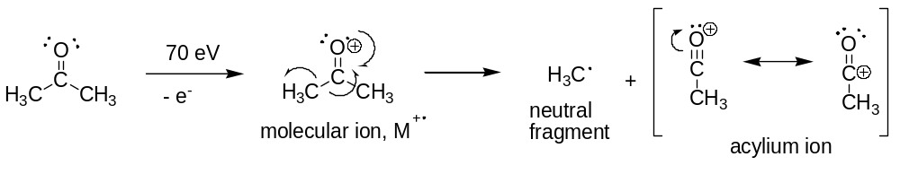
The fragmentation pattern can give you a tremendous clue as to the structure of the original molecule. As a matter of fact, scientists who have a very good understanding of mass spectrometry and fragmentation patterns can often solve the complete structure of an unknown simply from the mass spectrum. Fortunately, in this lab, structures have been limited to choices that will display very different fragmentation patterns for a given molecular mass. Later in the semester when you are asked to solve a full unknown, you will be allowed to combine mass spectral data with NMR and IR data to determine the structure.

One thing that complicates mass spectra a bit is that most elements are composed of a mixture of isotopes. (See Table 1.) Because the mass spectrometer can distinguish one unit mass differences, you will see peaks in the mass spectrum that correspond to the heavier isotopes. The natural abundance of ¹²C is 98.89% while the natural abundance of ¹³C is 1.11%. Any peak M in a mass spectrum that contains 1 carbon atom will have a peak one mass unit higher (M+1) that is ~ 1% of the size of peak M due to the heavier ¹³C nucleus in about 1% of the ions. That’s negligible. However, when you have compounds with more carbon atoms, you have a higher probability that some of those carbons will be ¹³C nuclei. So, as the number of carbon atoms increases, so does the size of the M+1 peak. For instance, a molecule that contains 10 carbon atoms will have approximately 89% ¹²C and 11% ¹³C. That’s certainly large enough to see on the mass spectrum. Be careful not to confuse the M+1 peak with molecular ion peak!

Table 1. Isotopic Abundances of “Organic” Elements
Element | Isotope (%) | M+1 Isotope (%) | M+2 Isotope (%)
Hydrogen | ¹H (99.98%) | ²H (0.016%)
Carbon | ¹²C (98.89%) | ¹³C (1.11%)
Nitrogen | ¹⁴N (99.64%) | ¹⁵N (0.36%)
Oxygen | ¹⁶O (99.8%) | ¹⁷O (0.04%) | ¹⁸O (0.2%)
Fluorine | ¹⁹F (100%)
Phosphorus | ³¹P (100%)
Sulfur | ³²S (95%) | ³³S (0.74%) | ³⁴S (4.22%)
Chlorine | ³⁵Cl (75.5%) |  | ³⁷Cl (24.5%)
Bromine | ⁷⁹Br (50.6%) |  | ⁸¹Br (49.4%)
Iodine | ¹²⁷I (100%)

Molecules and fragments containing chlorine and bromine will show large M+2 peaks. For chlorine, the M+2 peak will be about one-third the size of the M peak because the natural abundance of ³⁷Cl is about one-third the natural abundance of ³⁵Cl. For bromine, the M+2 peak will be almost the same size as the M peak because ⁷⁹Br and ⁸¹Br have almost identical natural abundances.

Another helpful piece of information is that molecules containing only C, H, O, S, P, and the halogens will always have an even numbered molecular ion peak. Molecules with an even number of nitrogen atoms will also have an even numbered mass. Due to the trivalent nature of the nitrogen atom, molecules containing an odd number of nitrogen atoms will have an odd molecular mass (the nitrogen rule.) So, if you have an odd molecular mass, you know you have an odd number of nitrogen atoms. Conversely, if you do not have nitrogen atoms in your molecule and you have an EVEN fragment ion, some rearrangement took place to create it. You cannot get even mass fragments from even mass molecules.

Interpreting Mass Spectra: A good place to start your analysis is to determine the mass of your unknown. Although not all compounds yield a mass spectrum with a molecular ion peak, all of these unknowns do. And since these unknowns contain only C, H, O, and/or halogens, all the molecular masses will be even numbers. Keep in mind that if you have a bromine atom present in the compound, you will see a significant M+2 peak that is about the same intensity as the M peak. Use the M, not the M+2, to identify the mass of the unknown. The same concept applies to chlorine. Expect to see an M+2 peak that is about one-third the size of the M peak.

For these unknowns, once you have determined the mass, you have limited your choice of structures to only a few compounds which will have drastically different fragmentation patterns. Begin analyzing the choices of compounds. Determine where given compounds are likely to fragment and see if your spectrum has peaks at the masses that corresponds to the fragments. Recall the fragmentation typically occurs at thermodynamically favorable locations within the molecule, such as at a branch in the carbon backbone, beside a C=O, or at the benzylic carbon. It is also helpful when calculating masses to use the predominant isotope mass (1 for H, 12 for C, 16 for O, 35 for Cl, and 79 for Br) NOT the average atomic mass of a mole of atoms, as is shown on the periodic table. You may find it helpful to bring a calculator with you to lab.

Keep in mind that you have a spectrum in which multiple molecules are being ionized and are fragmenting. The mass spectrum will be a combination of all the possible fragmentations. For instance, one parent molecule may lose a methyl group. Therefore, you may see a peak in the mass spectrum that is M-15, 15 being the mass of CH₃. Another molecule of the same compound may lose an ethyl group instead and give you a M-29 peak (CH₂CH₃ = 29). It is also possible that a series of fragmentation (or rearrangements) may occur. The molecule could lose a CH₃ and then a CH₂.

Report: Before you leave lab, turn in your full report (duplicate notebook pages and the spectra) for all three MS unknowns. Be sure to include your unknown number and the corresponding structure in an easy-to-read format. One paragraph describing how you identified each unknown is appropriate.

Possible Structures for MS Unknowns

Mass 58
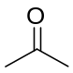
acetone butane

Mass 72
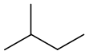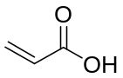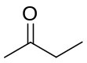
2-methylbutane propenoic acid 2-butanone

Mass 74
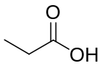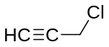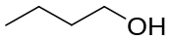
propanoic acid 3-chloropropyne 1-butanol

Mass 86
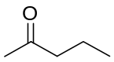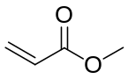
2-pentanone hexane methyl acrylate

Mass 100
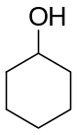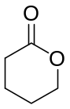
heptane cyclohexanol δ-valerolactone

Mass 106
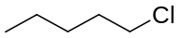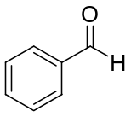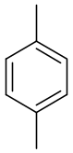
1-chloropentane benzaldehyde p-xylene

Mass 108
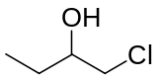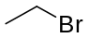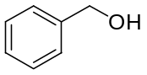
1-chloro-2-butanol bromoethane benzyl alcohol

Mass 112
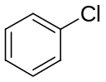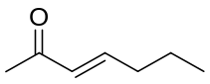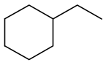
chlorobenzene 3-hepten-2-one ethylcyclohexane

Mass 120
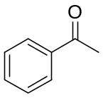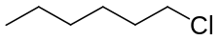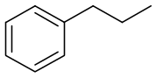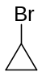
acetophenone 1-chlorohexane propylbenzene bromocyclohexane

Mass 122
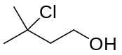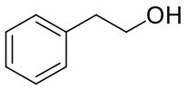
3-chloro-3-methyl-1-butanol 2-phenylethanol

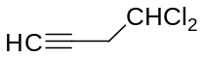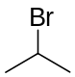
4,4-dichloro-1-butyne 2-bromopropane

Mass 140
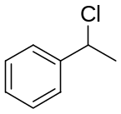
1-decene 1-chloro-1-phenylethane

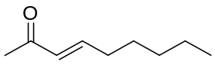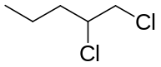
3-nonen-2-one 1,2-dichloropentane

Mass 156
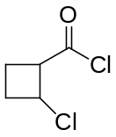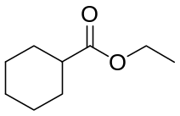
2-chlorocyclobutanecarbonyl chloride ethyl cyclohexanecarboxylate

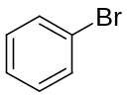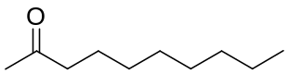
bromobenzene 2-decanone

Mass 182
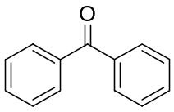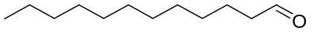
benzophenone dodecanal

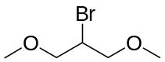
2-bromo-1,3-dimethoxypropane

Mass 184
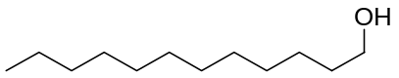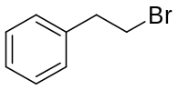
1-dodecanol 1-bromo-2-phenylethane

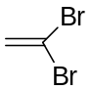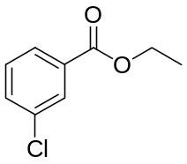

1,2-dibromoethene ethyl 3-chlorobenzoate

