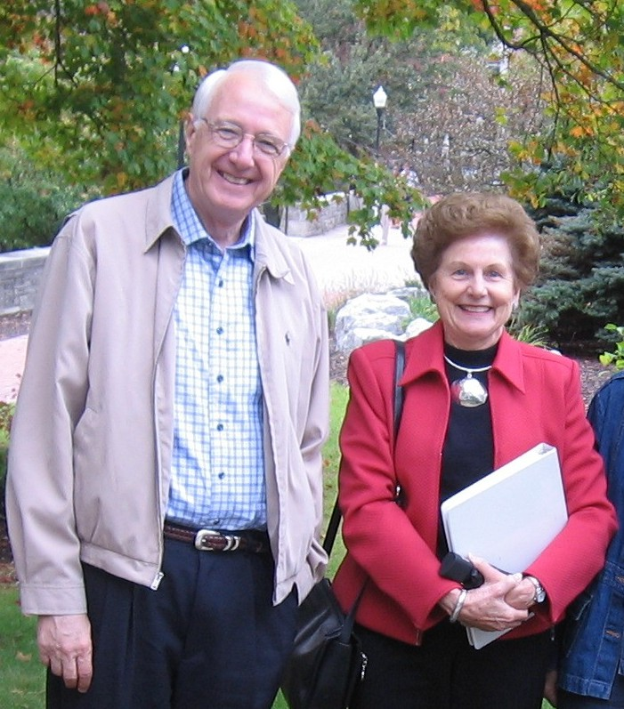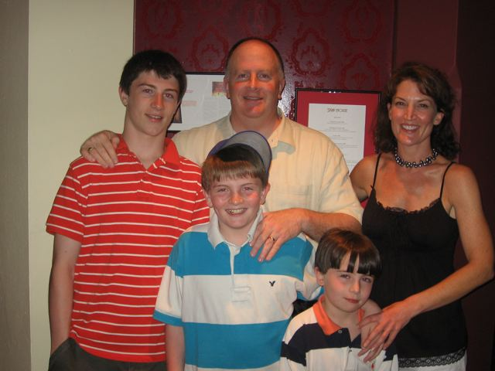
Dave and Lin @ Denison, June 07 Tom & Alison with Joe, Andrew, and Jack
River Forest, Illinois April 07

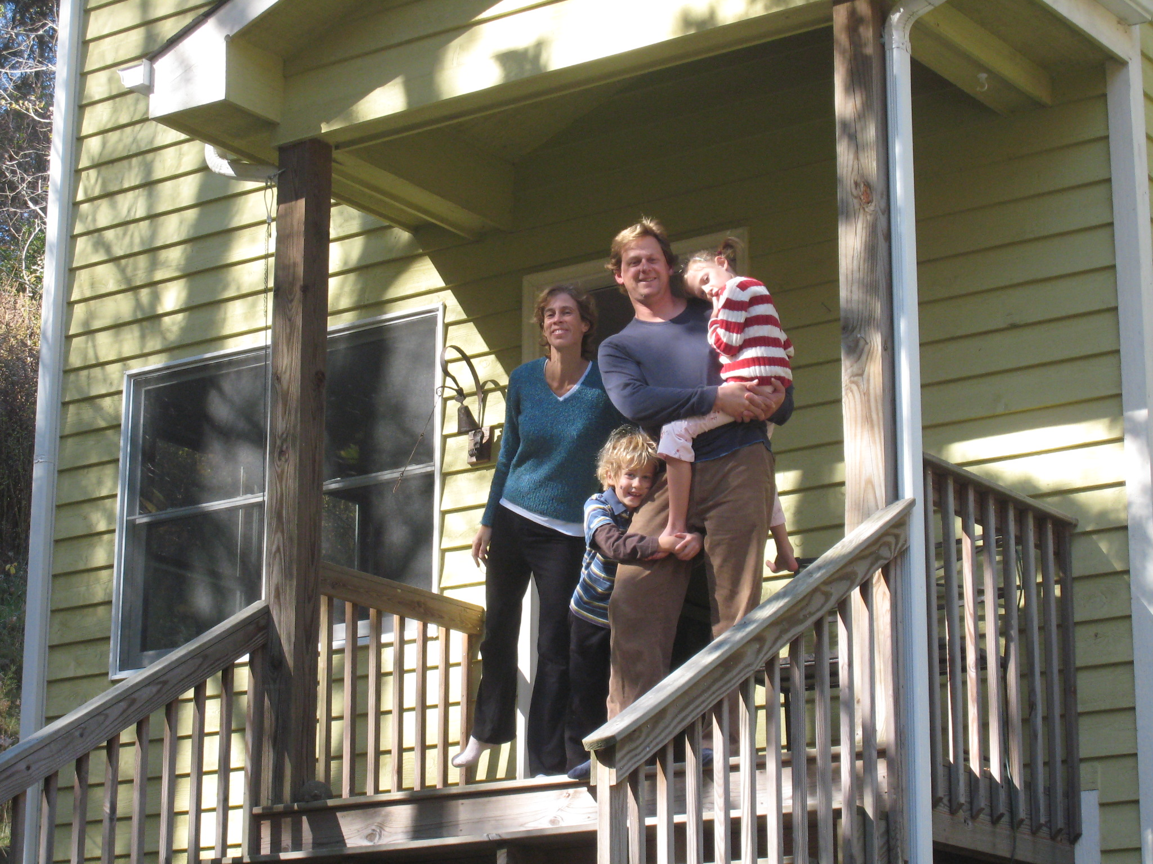
Karla and Dirk with twins, Alexander (lower) and Zoe
At their home in Boone, N.C. October 07

