Nitration of Toluene and determination of product distribution.

Purpose
- Study electrophilic aromatic substitution reaction (EAS)
- Study regioselectivity for EAS reactions

Chemicals Materials
150 – mL beaker
Toluene 400-mL beaker
Sulfuric acid (conc.) 125-mL flask
Nitric acid (conc.) Separatory funnel
Ice
Dichloromethane
2M NaOH

Introduction

Benzene rings are components of many important natural products and other useful organic compounds. Therefore, the ability to put substituents on a benzene ring, at specific positions relative to each other, is a very important factor in synthesizing many organic compounds. The two main reaction types used for this are both substitutions: Electrophilic Aromatic Substitution (EAS) and Nucleophilic Aromatic Substitution (NAS). The benzene ring itself is electron-rich, which makes NAS difficult, unless there are a number of strongly electron-withdrawing substituents on the ring. EAS, on the other hand, is a very useful method for putting many different substituents on a benzene ring, even if there are other substituents already present. Electrophilic Aromatic Substitution chapter describes the factors involved in the regioselectivity for EAS reactions using benzene rings, which already have substituents on them.

In this experiment you will put a nitro (—NO₂) group on a benzene ring, which already has a methyl group, attached to it (methyl benzene - Toluene). The actual electrophile in the reaction is the nitronium ion (NO₂⁺), which is generated in situ ("in the reaction mixture" HNO₃/H₂SO₄) using concentrated nitric acid and concentrated sulfuric acid.

Here is the general mechanism for the the nitration of just a benzene ring. Remember, you will be nitrating toluene which can produce three different isomers as well as potentially di-nitration.

Scheme I
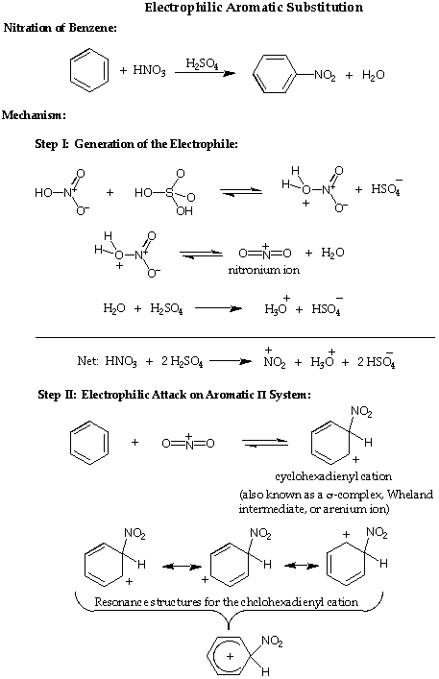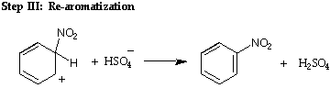

Procedure

Safety Note

Caution: Avoid contact with the acids used in this experiment and the reaction product. Prevent contact with the skin, eyes, and clothing; work in the hood. An acid spill is neutralized using solid sodium carbonate or bicarbonate. The reaction is highly exothermic. A vigorous reaction will occur if the acid mixture is added too rapidly to the Toulene

Concentrated nitric acid and concentrated sulfuric acid are both strong oxidizers, and strongly corrosive--wear gloves while handling them, and avoid breathing their vapors. Toulene is an irritant -- wear gloves while handling them. Dichoromethane is a flammable liquid, and is toxic -- no flames will be allowed in lab, wear gloves while handling it, and avoid breathing its vapors.

WORK INSIDE THE HOOD!!!!!!!!!

Working in Pairs, you will perform the nitration of toluene. You will submit your product samples for GC/MS analysis. Be sure to label each vial so you can keep track of which sample is which.

Start heating about about 200 to 300 mL of water to about 50C.
In an ice bath add 1.5 mL of toluene to a 125-ml. Erlenmeyer flask add approximately 4.0 ml. of concentrated sulfuric acid (drop-wise while stirring with a magnetic stir bar). Continue to cool the mixture while adding 2.0 ml concentrated nitric acid (measured in 10- ml graduated cylinder) drop-wise using a small pipette and mix well. Continue to cool the reaction mixture. In the hood, allow the reaction mixture to stand at room temperature for about five minutes. Float the 125-ml flask in a 400-ml beaker hot water bath. Remove the flask occasionally and swirl the content carefully or stir with magnetic sit bar. After fifteen minutes of heating pour the reaction mixture into 50-ml of ice water contained in a 150- ml beaker. If sulfuric acid is about 18M and nitric acid is about 16 M calculate the amount of 2M NaOH required to neutralize the acid. Add this amount of base slowly with stirring. You may need to cool the reaction by adding ice to the beaker. Check with pH paper as you approach neutralization.

Pour the reaction into a separator funnel and extract wit 3x25mL portions of dichloromethane. Combine all the organic portions in one flask and dry over magnesium sulfate. Filter into a round bottom and rotovap off solvent.

Make sample for GC-MS by adding 10 uL to 1mL of heptane.

Post lab questions:

- Draw the mechanism for the nitration of Toluene.
- Explain the distribution of products.

