Prior to lab obtain the literature melting point values of benzoic acid, aspirin, acetanilide, acetaminophen, and phenacetin. You might try looking in The Merck Index, the CRC Handbook of Chemistry and Physics, the Aldrich Chemical Catalog, or an online chemical supplier such as Sigma-Aldrich at http://www.sigma-aldrich.com. The NIST Chemistry WebBook is another valuable source of information. http://webbook.nist.gov/chemistry/ Even the Physical and Chemical Properties section of the Material Safety Data Sheet (MSDS, many available online) will typically give the melting point. Provide a reference for the source you choose.

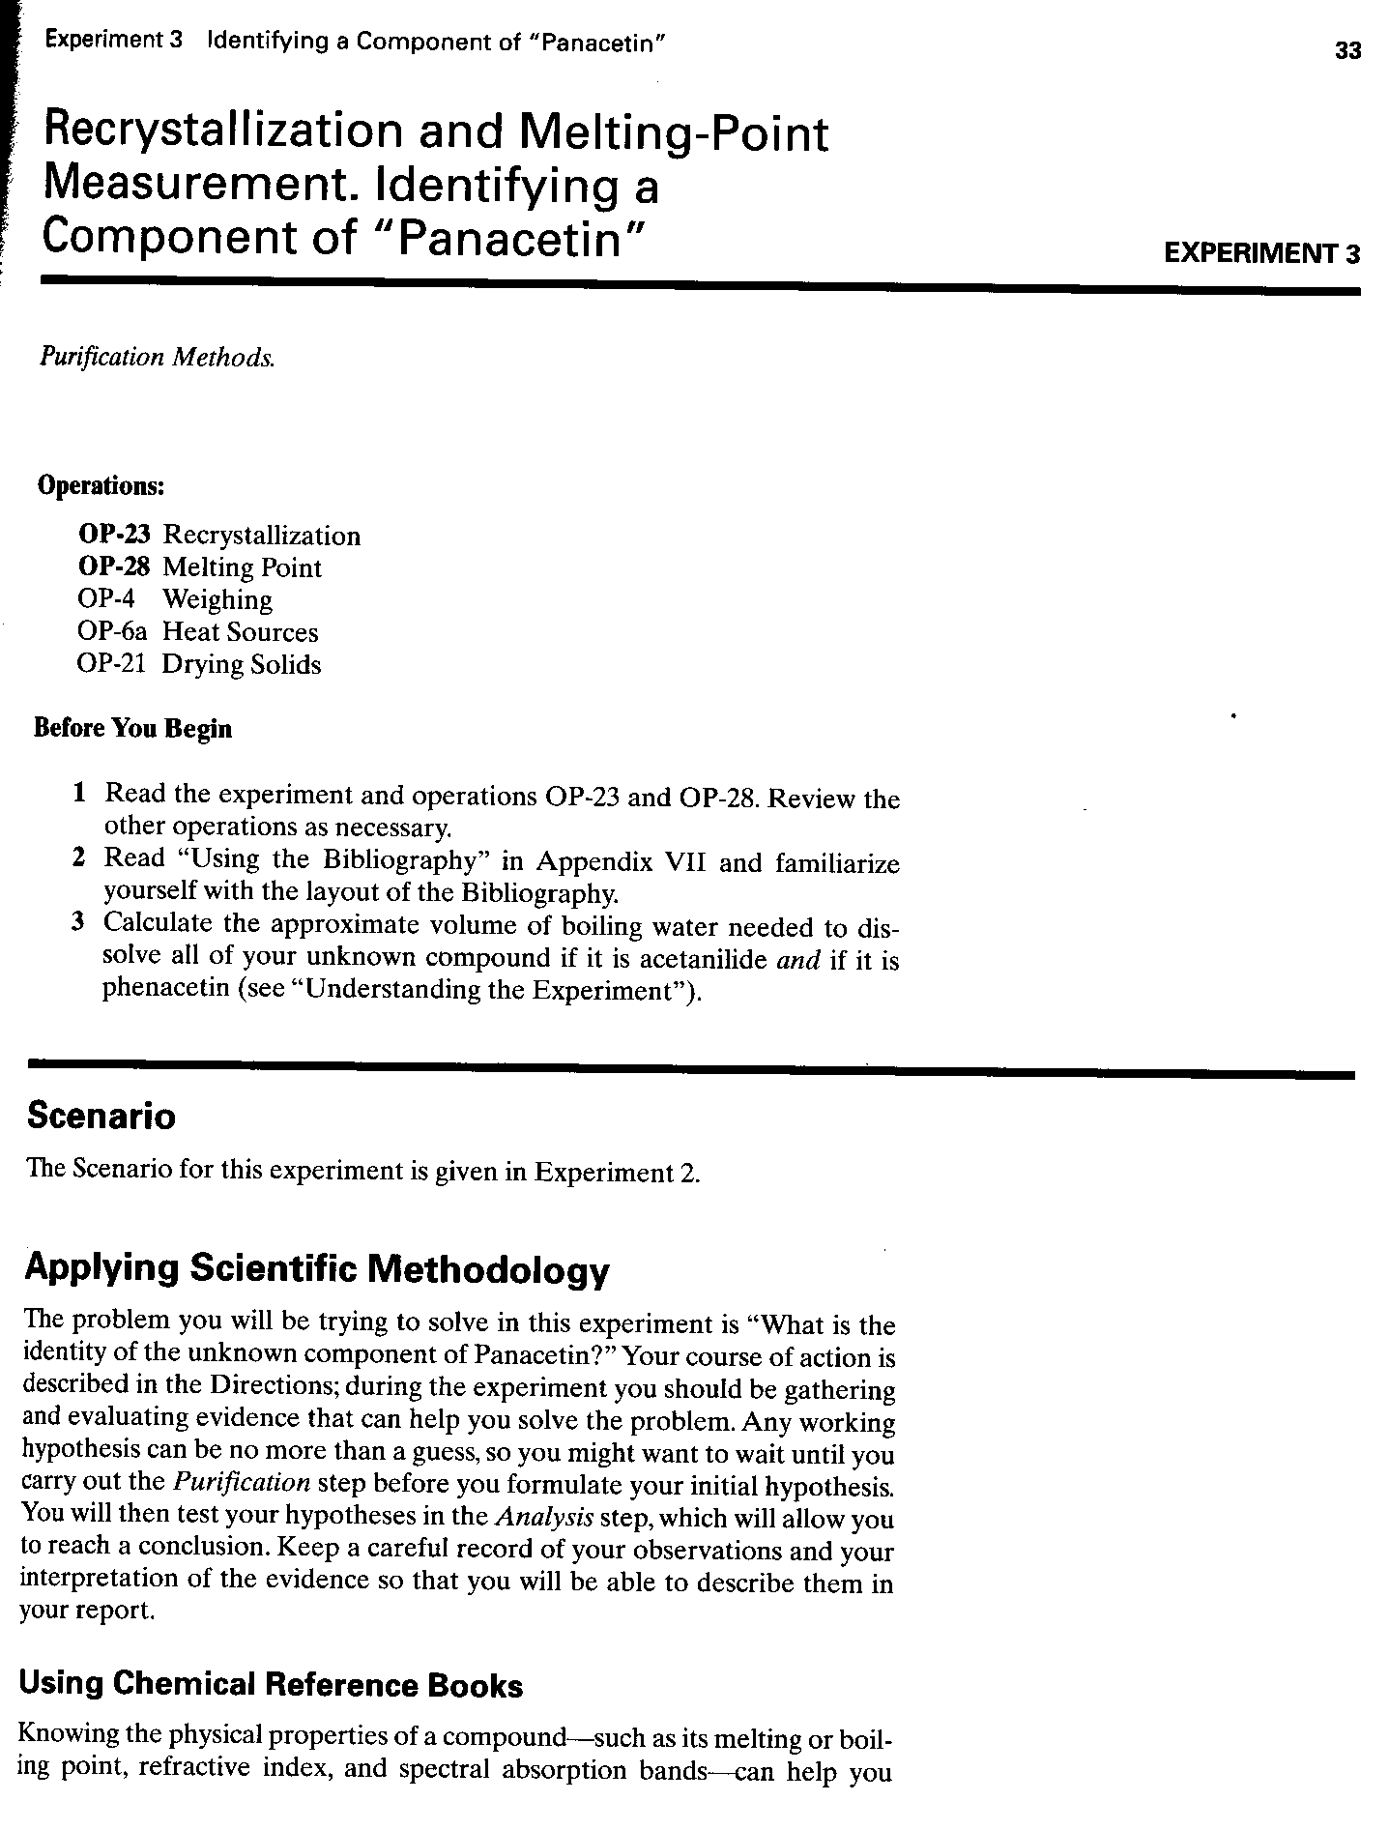
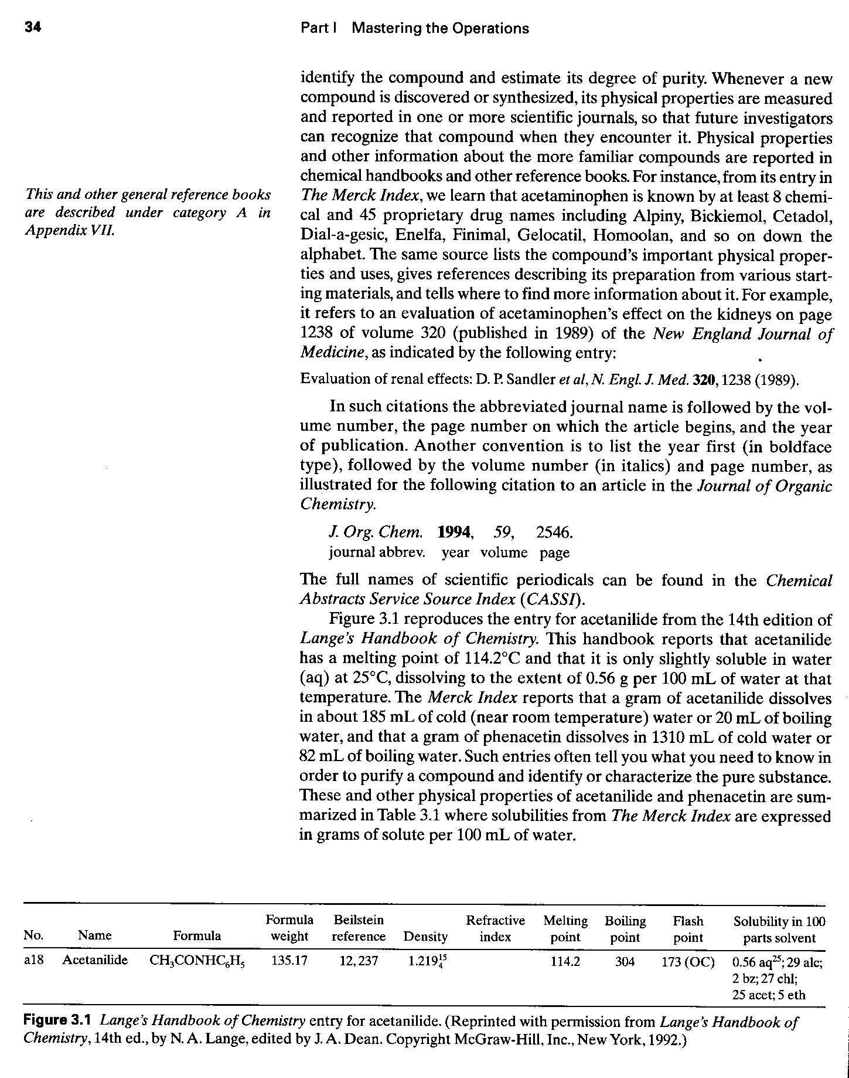

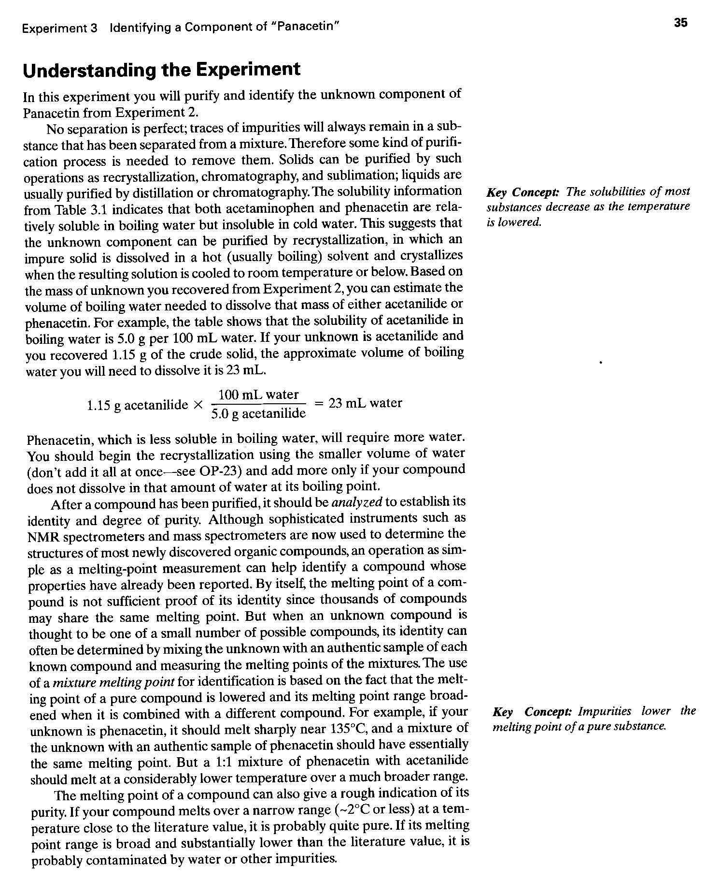

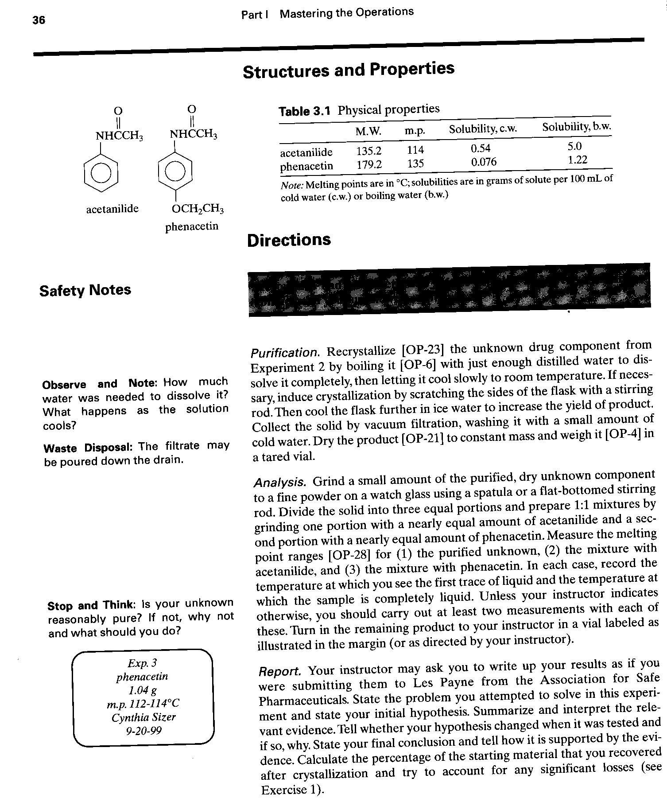
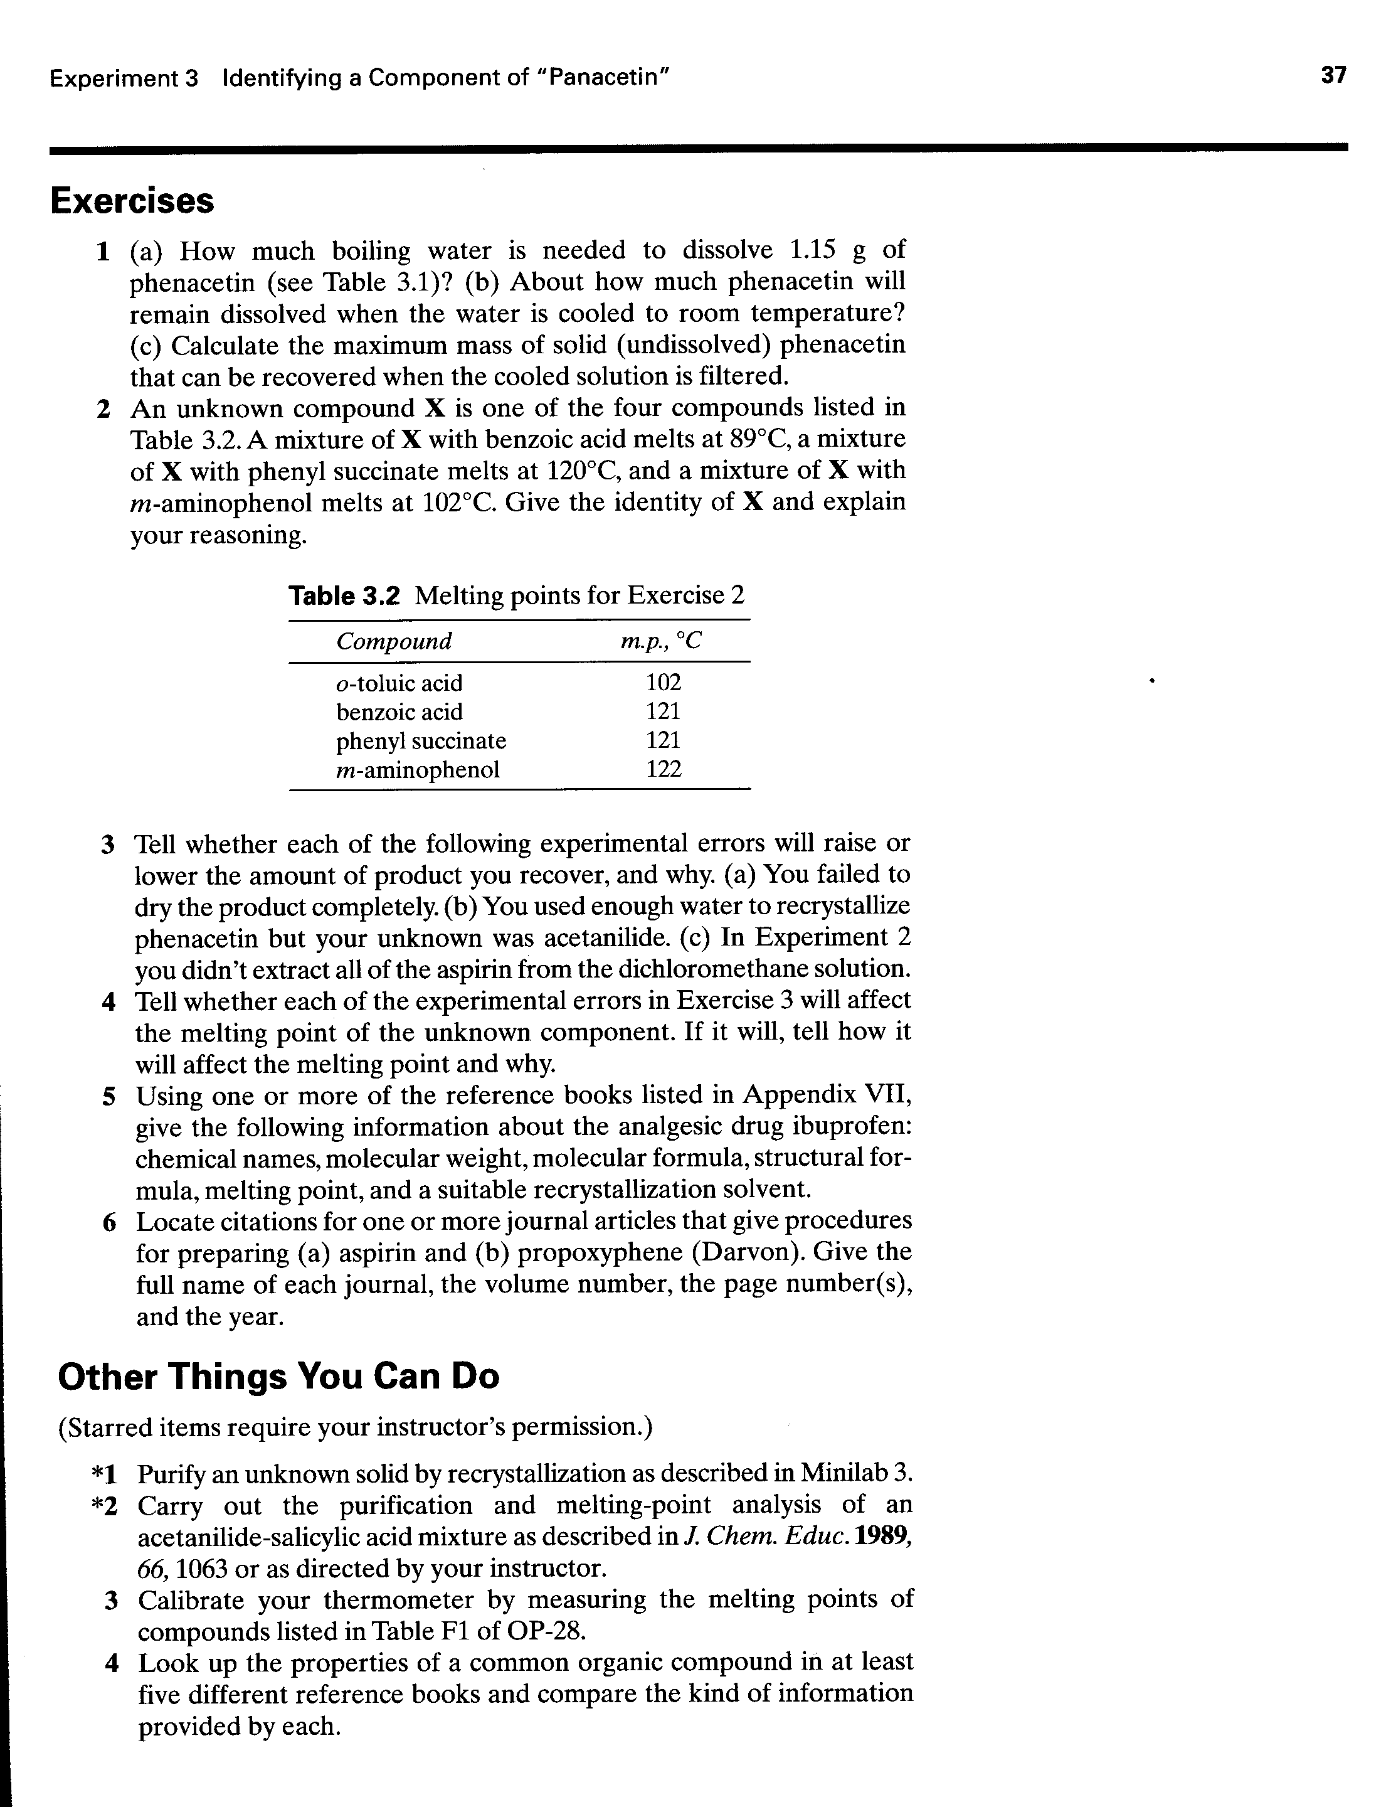

(Adapted from John W. Lehman, Operational Organic Chemistry, A Problem-Solving
Approach to the Laboratory Course, Prentice Hall, 1999.)

