Note: most of the “operations” mentioned in this handout are described in the Zubrick text or online. As with any organic lab, if you do not do the pre-lab assignments for this experiment, you may find yourself very frustrated and confused in the lab. You may also find it difficult to finish the lab in the allotted time frame if you do not fully understand the experiment prior to beginning. In addition to this handout, it is imperative that you read material on gravity (Zubrick) and vacuum (online) filtrations, Rotary Evaporation (Zubrick and online), and Extraction (Zubrick and online) prior to week 1 of this lab.

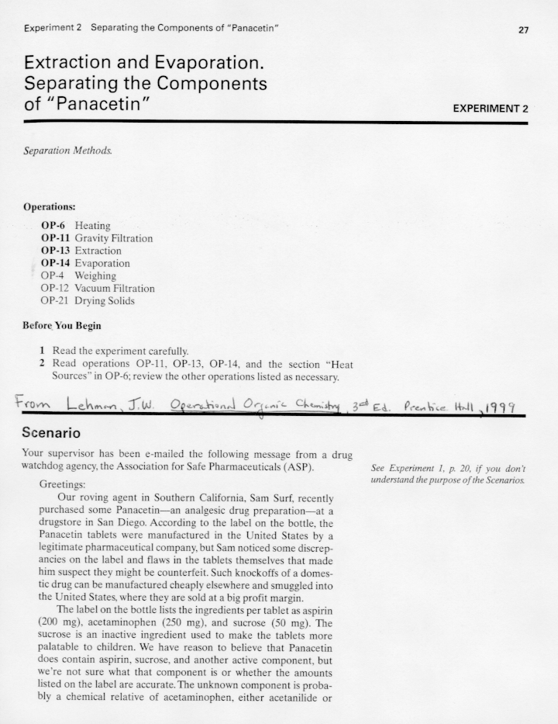

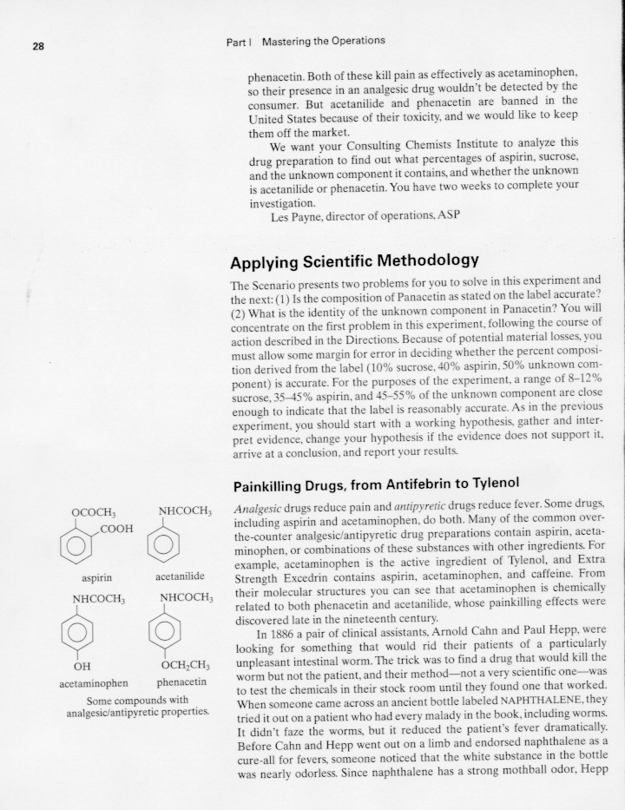
Obtain the literature melting point values of benzoic acid, aspirin, acetanilide, acetaminophen, and phenacetin. You might try looking in The Merck Index, the CRC Handbook of Chemistry and Physics, the Aldrich Chemical Catalog, or an online chemical supplier such as Sigma-Aldrich at http://www.sigma-aldrich.com. The NIST Chemistry WebBook is another valuable source of information. http://webbook.nist.gov/chemistry/ Even the Physical and Chemical Properties section of the Material Safety Data Sheet (MSDS, many available online) will typically give the melting point. Provide a reference for the source you choose.

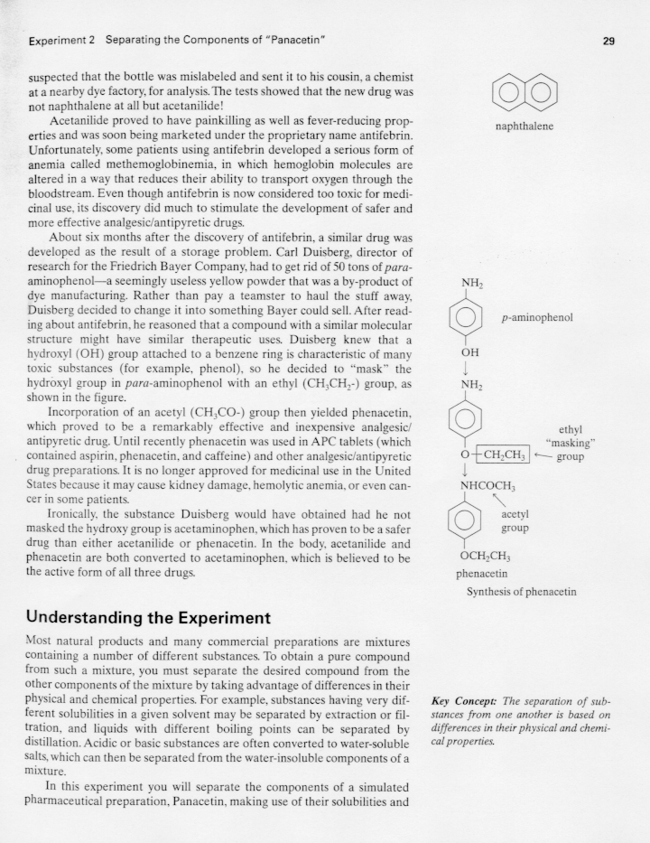

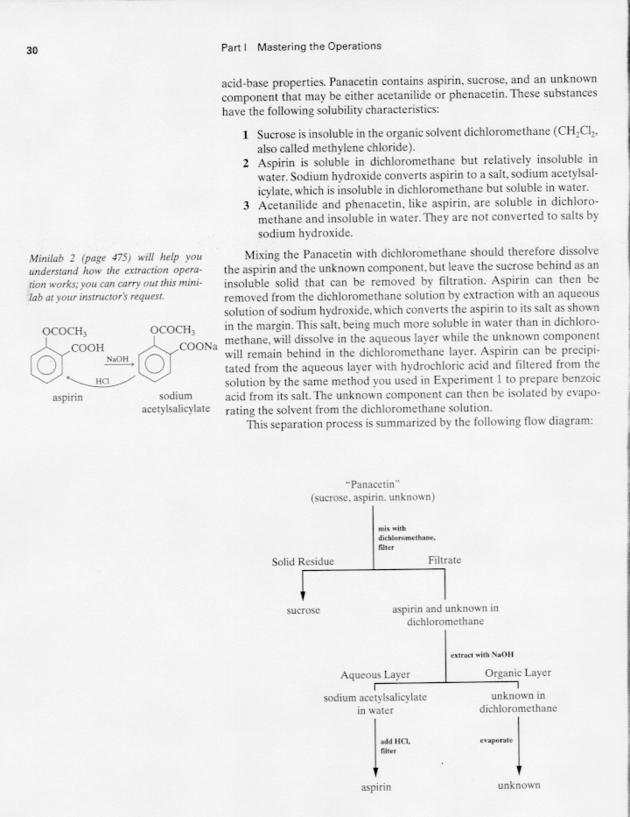
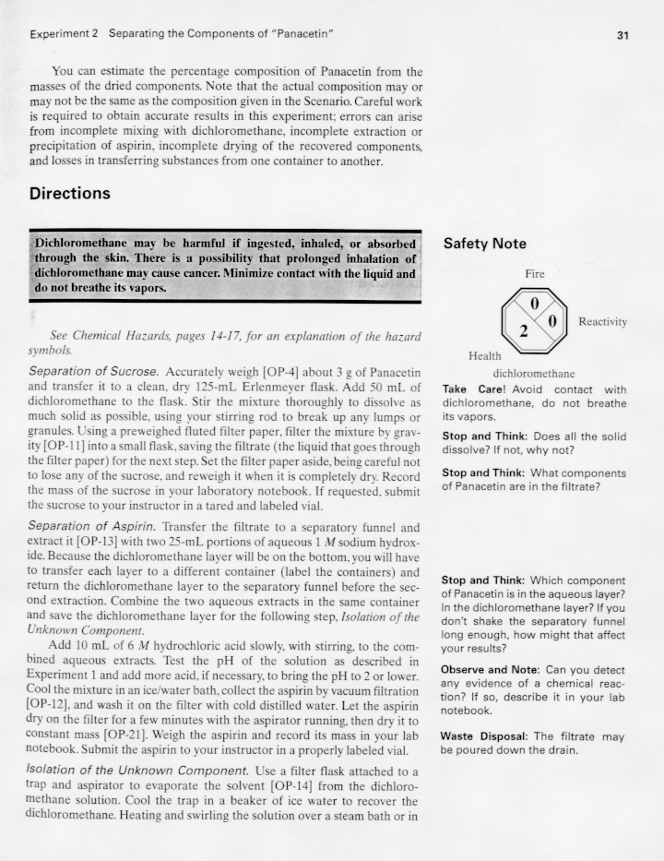
Notes: 1) You will be provided with 6 M HCl, but you will be expected to make your own 1M NaOH solution from NaOH pellets. Determine how much 1M NaOH you will need, and calculate how to make the solution prior to lab. 2) It is very important that you cool the aspirin solution before filtering and use a small amount of cold water to rinse the product. 3) To isolate the unknown, dry your CH₂Cl₂ solution with anhydrous MgSO₄ or Na₂SO₄, filter or decant, and then use the rotovap to remove the solvent.
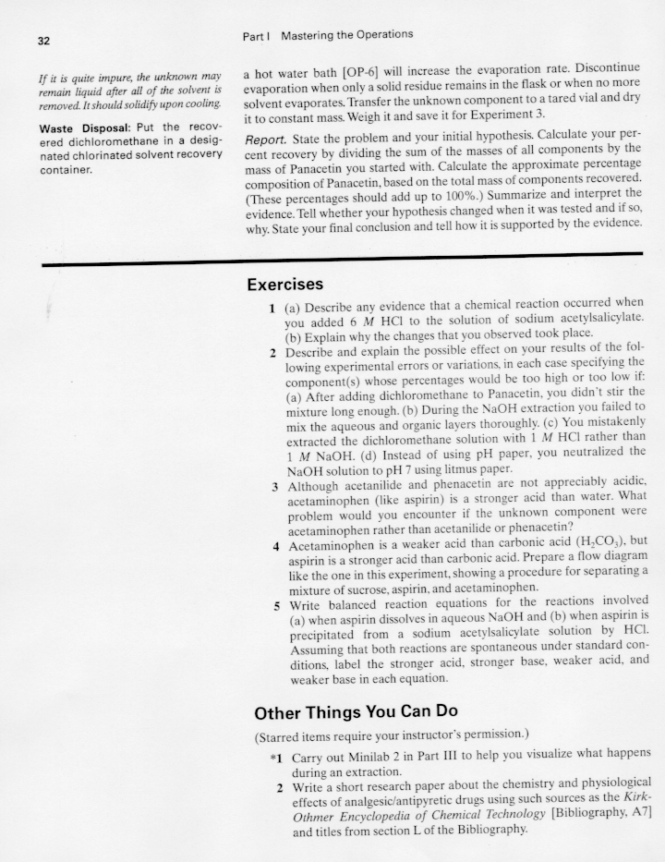

Notes: 1) Be sure to identify the unknown component of your painkiller and explain how you came to your conclusion. 2) After you have calculated the percent composition of the painkiller, determine if it matches the Panacetin label.

(Adapted from John W. Lehman, Operational Organic Chemistry, A Problem-Solving
Approach to the Laboratory Course, Prentice Hall, 1999.)

