This Document contains information for a new NMR user. Carefully read and accomplish each section before moving to the next. If you can’t finish a section please request help.

General Operating Procedures:
Requesting an Account and training (required to join the listserv)
1) Send an email to Dr. Marcus Wright (wrightmw) requesting an account and training.
2) Read the following information and install the PC processing program prior to training.
3) Join the NMR News Email List to be kept up to date on instrument status
http://lists.wfu.edu/mailman/listinfo/nmrlab

Know These User Policies

1) Walk up access is from 8am to 8pm.
2) Time quotas: Experiments requiring more than 15 minutes must be run at night or approved by Dr. Wright

3) Nighttime Reservations (8pm to 8am) and directions can be made at http://www.wfu.edu/~wrightmw/reservations.html Login with wfulabs and password: signal2noise

You can take up to 15 minutes of spectrometer time at one login session. Locking and shimming requires about 5 min per sample and 2 min. to acquire an average 1D data set.. Here are some possible combinations you could run:

A) 1H NMR spectra on *two* different samples
B) 1H NMR spectrum on *one* sample if using MeOD and the special tune file for MeOD shimming
C) 1H and 13C128scan on *one* sample
D) 1H and 31P and 13C128scan on *one* sample

You can always setup more than this at one time but you must mark the excess experiment time as
*delayed *(change the sun to the moon). You could just wait 15 min then log back in and submit another
15 min without delaying anything. The advantage to delaying experiments is you don't have be there to
start them and you can submit as many as you want. The disadvantage is they will only run when the
instrument is idle. If you see your delayed samples continuously pushed back go to the machine, cancel
15 min worth of experiments and change to daytime then submit. Also, remember if an experiment's *acquisition* time is over 15 min and marked delayed then it runs after 8pm. You must have the instrument reserved to run after 8pm.

3) Orphaned samples are removed according to posted schedule and disposed.

4) ***NO heterogeneous samples.*** Instrument will fail to lock or will sit and try to lock over and over
and over and over........ Filter or centrifuge. *To filter an NMR sample:* Tightly pack a small piece of
cotton into a glass pipette using a long glass pipette. Add about 2-3 mm of celite to the top of the cotton
plug. Tap pipette on it's tip to compact celite filter bed. Add NMR sample to top of filter bed and force
through (if needed) into NMR tube.

5) Use 0.6 mL of your solvent, too high or too low solvent level effects shimming times and quality. Use about 10-15 mg for 1H, 19F and 31P samples or overnight 13C and 50-100mg for a 128 scan 13C.

6) ***SET THE SAMPLE HEIGHT.*** Sample will not spin if too low and can/will break the probe, too high can fail to lock and shim.

7) Put your sample in the lowest available (green) position holder avoids your experiment being skipped.

Mapping your hard drive to the NMR

You must be on campus and often the security settings require you to be in Salem Hall or use VPN.
1. Right click on the “My Computer” icon on your desktop
2. Choose “Map Network Drive”

3. In the “Folder” field of the window that pops up, type:
\\10.121.251.10\archive

4. Click on “Connect Using Different Credentials
5. Set the user name to: 10.121.251.10\advanced .
6. Set the password to: larmor1 (To help avoid confusion, that’s larmor then the number one.)
7. Click on “OK” then click “Finished”

Download and install the MNova license file

1. Make sure MNovaLite or any other version of Mnova have been installed. Click on the Window's key and press R at the same time. Enter and run the command: \\codesrv1\wake\Mestrelab
2. A new window will open then copy the Mestrelab.reg file to your desktop.
3. From your desktop, double click the Mestrelab.reg file and answer yes to all questions. . ***On Windows 8 you will need to authorize the install so read all caution message carefully***

Download and install MNova 9.0.0

Go to the following web site, download and install the software.
http://mestrelab.com/software/mnova/download/thank-you/?url=%2Fdownloads%2Fmnova%2Fwin%2Fmsi%2FMestReNova-9.0.0-12821.msi

Make sure you know where the msi file was downloaded. Go to the file and double-click to install. Answer yes to questions.

Using MNova
This version of the software works much like the previous version. Hover your mouse on an icon to see its description. There are several new features that will be discussed in classes or as you need. Please see the Help→Contents menu for specifics.

Short Set of Directions: (make sure mapfix has been run)
- You can only open NMR data from MNova. Open the “fid” file in 300current\data\”user”\”file name”\”exp number” folder.
- Frequently used icons:

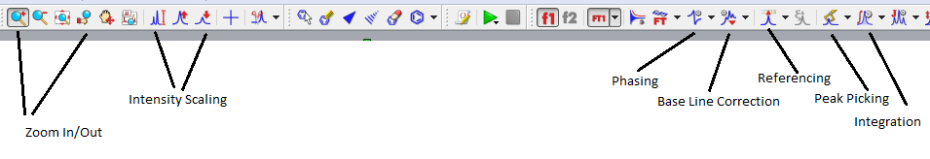
- If needed perform a Base Line Correction using the Auto or Whittaker Smoother method.
- Perform an Auto Phase Correction or Manual correction by choosing the icon and manual option. Left click and push the mouse forward and backwards to flatten the baseline around the red pivot line and right clicking and pushing/pulling the mouse flattens the baseline away from the pivot.
- Zoom (pick icon and left click drag) region around your Internal Reference (TMS or Solvent) and using the Reference icon set its chemical shift.
- With the Peak Pick ion you can perform an Auto or Manual Peak Pick. Manual mode: left click on the left side of spectrum and drag the threshold line to encompass your peaks. The top threshold line should be below the top of the peaks to be selected and displayed.
- Perform a the Auto or Manual Integration. Manual mode: choose icon and manual option then left click and drag on either side of peak, giving some room before and after each peak to establish a flat baseline if possible. Right click on the integral trace (sigmoidal line) above a known peak and set the Normalized value to a known integer and press enter.
- Print or copy spectrum for presentation.

To Predict NMR spectra and Stack the results
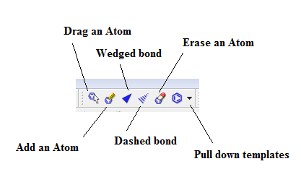
1. Starting with a new page draw the molecule you wish to simulate.
2. Use the tool pallet to make rings and chains. To change a carbon to another atom deselect the current tool and then click on the carbon to change and enter the lower case element symbol.
3. Once drawn go to the top menu and choose Predict→ 1H spectrum.
4. To make another prediction right click the left navigation window and choose Create New page. Repeat drawing and predicting.
5. Once all of the same spectra are drawn you can superimpose or stack the spectra by first left clicking on one of the small navigation windows on the very left then holding shift and click on the other spectra to stack. Next, go to the top menu and choose Stack and choose your desired option. You can also choose Auto Scale form the Stack menu as well.

Processing MS Data from the SAMBA sever:
After running Mapfix.exe and opening MNova go to File→Open and navigate to your data folder. Double click on the DATA.MS file and you should see the total ion chromatogram (TIC) in the top window and a mass spectrum in the lower window.
You can zoom in and out of each window by clicking on a window and using the zoom or full spectrum tool.
If the TIC is selected by clicking on it the crosshair tool will display the mass spectrum at a point by simply clicking on the TIC or left click drag on the TIC for and average mass of that region. So to display the MS for a well resolved peak grab the crosshair tool and left click and drag the peak.
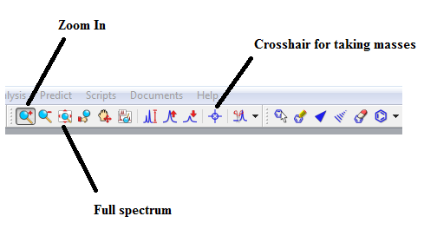

Most of the time peaks in the TIC are correctly selected. But if you need to integrate peaks in the TIC manually right click on the TIC and choose Add Peak. Then left click and drag on the peak. You can also let the program detect peaks as well. To change the way peaks are detected right click and choose Detect Peak Options

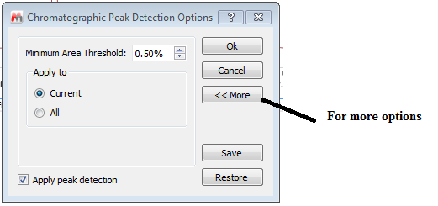
Clicking More gives you the chance to change the Sensitivity or “Threshold” to include or exclude peaks.
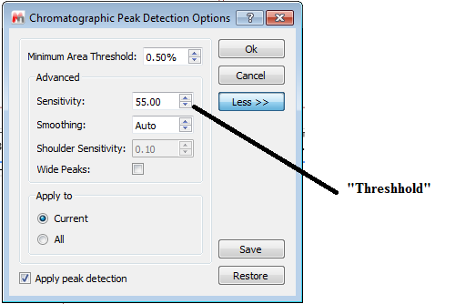

To display a table of the relative areas of the selected peaks in the TIC go to View→Tables→Mass Peaks. The choose Paste to put on the data. You can select and drag the table where you want.
To display a table of the fragments in the mass spectrum just select the ms window and then go to View→Tables→Mass Peaks. Paste and move to where you like.

