Exam 2
Chemistry 122

March 29, 2004

Do not open or begin this exam until instructed. This exam consists of 5 pages plus the cover page. Before starting the exam, check to make sure that you have all of the pages. The exam has a total of 100 points and includes 13 questions. Only legible answers written on the exam will be considered for grading. All pertinent information needed for the exam is given. Notes and textbooks are not permitted. This exam is administered under the Wake Forest Honor Code.

Name_______________________________________

- (3 points) What portion of the electromagnetic spectrum enhances stretching and bending of bonds?

- (4 points) List two ways that you could distinguish between 1-bromo-2-methylpropane and 1-butanol using spectroscopic methods that we have discussed. Be brief but specific.

- (4 points) Provide the structure of any organic compound that should display a pentet in the ¹H NMR spectrum. For clarity, circle the proton(s) that will appear as a pentet.

- (3 points) Which of the following alkenes will give off the most heat upon catalytic hydrogenation?

- (6 points) Provide IUPAC accepted names for the following compounds.

- (3 points) Provide a structure for (Z)-3-methyl-2-penten-1-ol.

- (3 points) Which of the following nucleophiles will react fastest with iodoethane?

- (6 points) For each set which compound would react fastest by an S_{N}1 mechanism?

a. CH₃Br CH₃CH₂Br (CH₃)₂CHBr (CH₃)₃CBr no difference

b. (CH₃)₂CH-I (CH₃)₂CH-Cl (CH₃)₂CH-Br (CH₃)₂CH-OSO₂CF₃ no difference

- (3 points) Which of the following alkoxides would be most likely to act as a base, not as a nucleophile, toward 1-bromopentane?

CH₃ONa CH₃CH₂ONa (CH₃)₂CHONa (CH₃)₃CONa no difference

- (30 points, 3 each) Provide the major organic products for the following reactions. If elimination predominates and more than one alkene can be formed, indicate which alkene is formed in highest yield.

- (10 points) Provide a complete electron-pushing mechanism that explains how the given product is formed. Include any byproducts as they are formed.

- Match the following compounds with their IR spectra. (5 points) Label at least one peak in each IR that helped you conclusively identify the structure. (10 points)

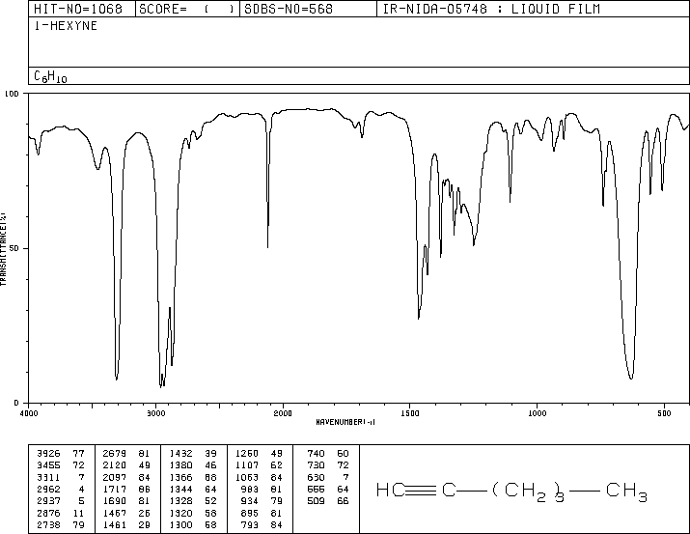

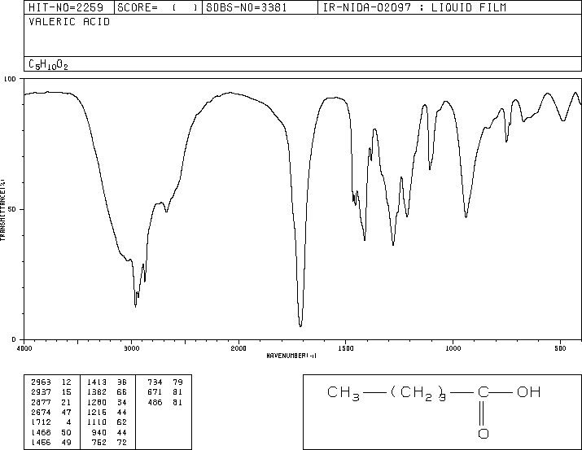

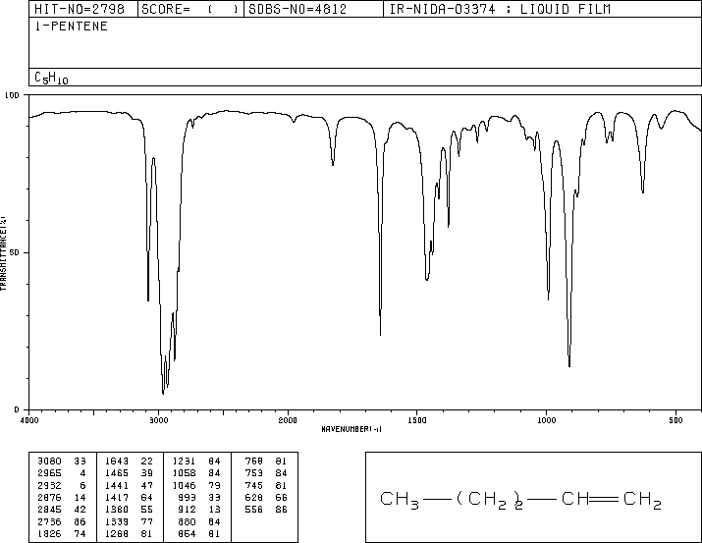

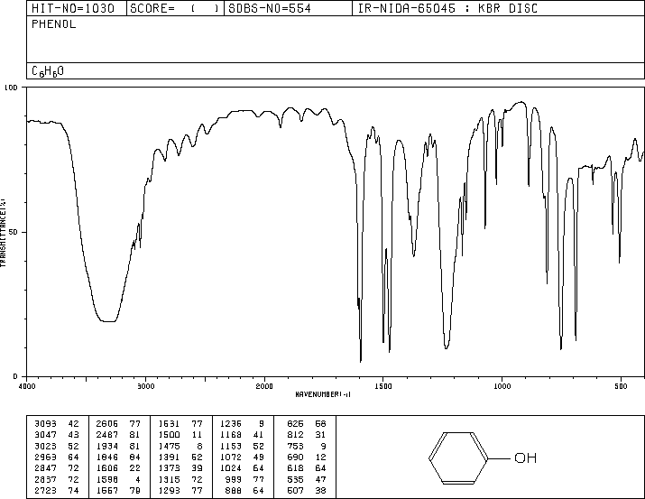

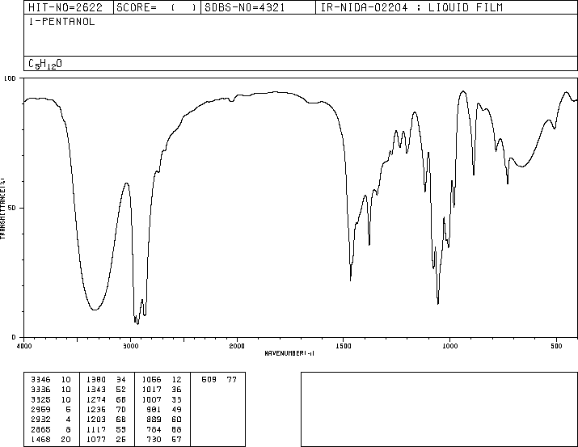
- (10 points) Determine the structure of the following C₈H₈O₂ compound. Partial credit will be awarded if you solve pieces of the final structure and show your reasoning.

¹H NMR: ¹³C NMR (δ in ppm): 56, 114, 130, 132, 165, 191
9.8 ppm 1H singlet
7.8 ppm 2H doublet
7.0 ppm 2H doublet
3.8 ppm 3H singlet

IR:
